**Steps to install DBATools in Windows 7 Operating System.**

1. Open PowerShell with "Run as Administrator".

2. Execute below script in powershell window. (or) You can download it from below links.



<https://github.com/RichieBzzzt/dbatoolsdebug/blob/master/install.ps1>

<https://raw.githubusercontent.com/RichieBzzzt/dbatoolsdebug/master/install.ps1>

3. Post installation, Type following command in powershell window.

Get-Command

This would list out all powershell modules which got installed related to SQL Server Adminstration.

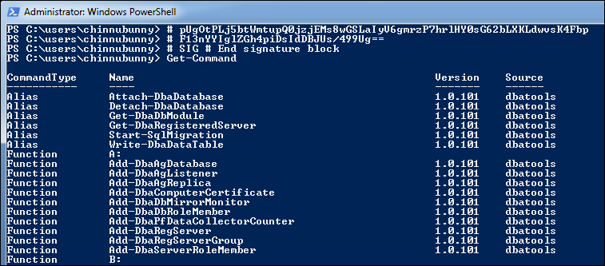

Reference sites for DBA Activities using DBATools Powershell modules:

<https://dbatools.io/getting-started/>

<https://www.sqlshack.com/dbatools-powershell-module-for-sql-server/>

Prepared by **Praveen Madupu (Sr SQL DBA)**

**Mb: +91-9866130093 Mail: praveensqldba12@gmail.com**